**User:**

I am a Mechanical Designer, proficient in SolidWorks drafting, and a recent graduate of the University of New South Wales. I would like you to act as both a knowledgeable designer who can provide me with design expertise and a professional engineering designer who can act as a technical advisor to me when I have complex questions.

I like the minimalist and sleek design style of the energy harvesting device. It should look clean and modern without unnecessary details.

The energy harvesting device is planned to be deployed in a coastal urban environment in Australia. The design needs to take into account the city where it will be applied to ensure consistent energy output throughout the year. Installation must be straightforward. In terms of maintenance, the unit should be designed to minimise the need for frequent repairs and, where necessary, key components should be easily accessible.

The equipment must comply with Australian Standards for Electrical Equipment. The design should be compact to fit into the limited urban space where the installation is specified. Considering the budget of A$50,000, we should prioritise durable materials, balancing cost and longevity.

For this project, I favoured a bio-inspired design approach, using principles found in nature to optimise energy harvesting.

Based on the above background, I will be designing an energy harvesting device.

The energy harvesting device shall require three key modules:

1. The energy accumulation module functions to derive energy from an external source outside the energy harvesting device.

2. The energy storage module functions to store the accumulated energy inside the energy

harvesting device.

3. The energy utilization module utilizes the harvested energy to power other small devices such as sensors, heating/cooling devices, actuators, and low-power devices.

Please give me as many and reasonable and complete designs as possible.

**GPT:**

Designing an energy harvesting device for an urban coastal environment in Australia, with a focus on minimalism, sustainability, and practicality, is an exciting challenge. As a Mechanical Designer proficient in SolidWorks, your expertise in drafting will be essential in visualizing and refining these concepts. Let's break down the requirements and propose a design approach for each module.

1. **Energy Accumulation Module:**
   * **Design Concept:** Since the device will be deployed in a coastal city, leveraging wind or tidal energy could be highly effective. A sleek, vertical-axis wind turbine or a compact tidal energy converter could be incorporated. The design should be aerodynamic to minimize resistance and maximize energy capture.
   * **Materials:** Durable, corrosion-resistant materials like stainless steel or anodized aluminum are ideal for withstanding coastal conditions.
   * **Integration:** This module should be easily integrated with the other components, allowing for seamless energy transfer.
2. **Energy Storage Module:**
   * **Design Concept:** The storage unit should be compact yet capable of holding a significant charge. Lithium-ion batteries or supercapacitors are good choices, considering their energy density and longevity.
   * **Accessibility:** Design the module to be easily accessible for maintenance or replacement, with clear labeling and secure but user-friendly access points.
   * **Protection:** Ensure robust casing to protect against environmental factors like humidity, salt, and temperature fluctuations.
3. **Energy Utilization Module:**
   * **Design Concept:** This module should be versatile, capable of adjusting the output to power various small devices. It should include smart controls for efficient energy distribution.
   * **Connectivity:** Incorporate modular connectors or universal ports for ease of connecting different devices.
   * **Safety:** Ensure compliance with Australian Standards for Electrical Equipment, with features like circuit breakers, surge protectors, and grounding.

**Overall Design Considerations:**

* **Aesthetics:** Maintain a minimalist, sleek look with smooth lines and a modern finish. Avoid unnecessary external details.
* **Budget:** Balance the use of high-quality, durable materials with the A$50,000 budget. Focus on long-term durability to offset initial costs.
* **Bio-inspired Design:** Explore patterns and principles from nature that optimize energy efficiency, such as biomimicry in the shape and structure of the device, drawing inspiration from natural forms like leaves or shells for efficient energy capture and flow.

**Final Thoughts:** This initial design outline aims to meet the practical requirements of your project while aligning with the aesthetic and budgetary constraints. As a next step, detailed sketches or SolidWorks drafts can be created to further refine and visualize these concepts. Remember, iterative design and testing are key to achieving the optimal balance between form, function, and sustainability.

**User:**

Based on the information I provided earlier, are there any other details I should provide regarding the design of the energy harvesting device?

**GPT:**

Your initial description of the energy harvesting device is quite comprehensive, covering key aspects like design style, environmental setting, functionality, and budget. However, to refine the design further, you might consider providing additional details in the following areas:

1. **Specific Energy Source:** Specify the primary energy source you intend to harness (e.g., solar, wind, tidal, thermal). This will greatly influence the design of the energy accumulation module.
2. **Size and Space Constraints:** More precise dimensions or space limitations where the device will be installed can guide the compactness of the design.
3. **Target Energy Output:** A specific goal for energy output (in watts or kilowatts) will help in sizing the components appropriately and assessing the feasibility within the budget.
4. **Integration with Existing Infrastructure:** Information about how this device will interface with existing urban structures or systems could impact the design.
5. **Environmental Conditions:** Detailed information about the typical weather conditions, temperature ranges, and humidity levels in the installation area can help in selecting materials and designing for durability.
6. **User Interaction:** Details about how users will interact with the device, if at all, can influence design elements related to accessibility and user-friendliness.
7. **Regulatory and Safety Requirements:** Any specific Australian Standards or local regulations that must be met, especially concerning safety and environmental impact.
8. **Lifecycle and Sustainability Goals:** Information about the desired lifespan of the device and any specific sustainability goals (e.g., recyclability, energy efficiency standards) would be beneficial.
9. **Maintenance and Serviceability:** More details on anticipated maintenance intervals or serviceability requirements can guide the design of accessible and replaceable components.
10. **Aesthetic Preferences or Branding Requirements:** If there are any specific aesthetic preferences or branding elements that need to be incorporated into the design.

Providing these additional details will allow for a more tailored and feasible design, ensuring that the final product not only meets technical specifications but also aligns with practical and contextual needs.

**User:**

I like the minimalist and sleek design style of the energy harvesting device. It should look clean and modern without unnecessary details.

The energy harvesting device is planned to be deployed in a coastal urban environment in Australia. The design needs to take into account the city where it will be applied to ensure consistent energy output throughout the year. Installation must be straightforward. In terms of maintenance, the unit should be designed to minimise the need for frequent repairs and, where necessary, key components should be easily accessible.

The equipment must comply with Australian Standards for Electrical Equipment. The design should be compact to fit into the limited urban space where the installation is specified. Considering the budget of A$50,000, we should prioritise durable materials, balancing cost and longevity.

Based on previous outputs and above information, please give me as many and reasonable and complete designs as possible.

**GPT:**

Creating multiple complete designs for an energy harvesting device within the constraints of a single response is challenging, but I can outline several design concepts based on your requirements. Each concept will consider the minimalist and sleek design style, the coastal urban environment of Australia, budget, maintenance, and compliance with Australian standards.

**Design Concept 1: Wind Energy Harvester**

* **Structure:** Vertical-axis wind turbine with a sleek, cylindrical shape.
* **Materials:** Stainless steel for corrosion resistance, with a smooth, reflective finish.
* **Size:** Compact design, around 2-3 meters in height, suitable for urban spaces.
* **Maintenance:** Modular design for easy replacement of blades or generator components.
* **Energy Storage:** Integrated battery pack at the base, easily accessible for maintenance.

**Design Concept 2: Solar Energy Harvester**

* **Structure:** Slim, triangular frame holding high-efficiency solar panels.
* **Materials:** Lightweight aluminum frame with weather-resistant solar panels.
* **Size:** Modular panels, each around 1x1 meter, scalable based on space availability.
* **Maintenance:** Hinged panels for easy access to electrical components.
* **Energy Storage:** Battery storage system housed in a sleek, ground-level unit.

**Design Concept 3: Hybrid Solar-Wind Harvester**

* **Structure:** Combination of vertical-axis wind turbine and solar panels on the same structure.
* **Materials:** Combination of stainless steel for the wind turbine and durable solar panels.
* **Size:** Designed to maximize energy capture within a 3x3 meter footprint.
* **Maintenance:** Separate access points for wind and solar components.
* **Energy Storage:** Unified energy storage unit with smart management for both energy sources.

**Design Concept 4: Tidal Energy Harvester (if near water)**

* **Structure:** Submerged or semi-submerged turbine units.
* **Materials:** Marine-grade materials to withstand saltwater conditions.
* **Size:** Depending on tidal patterns, each unit could vary in size.
* **Maintenance:** Designed for easy detachment and servicing.
* **Energy Storage:** Energy transferred to a storage unit on land, possibly combined with solar panels.

**Design Concept 5: Kinetic Energy Harvester**

* **Structure:** Energy harvesting from pedestrian footfall or vehicular traffic.
* **Materials:** Durable, non-slip materials for surface, with internal piezoelectric elements.
* **Size:** Customizable to pathways or roads.
* **Maintenance:** Modular tiles for easy replacement.
* **Energy Storage:** Energy storage in adjacent, easily accessible utility boxes.

**General Considerations for All Designs:**

* **Compliance:** All designs comply with Australian Standards for Electrical Equipment.
* **Budget:** Focused on balancing cost and durability within the A$50,000 budget.
* **Aesthetics:** Each design adheres to a clean, modern, and minimalist aesthetic.
* **Installation:** Designed for straightforward installation in urban settings.

These concepts are starting points, and each can be further detailed and adapted through design iterations and simulations in SolidWorks or similar CAD software. Remember, prototype testing and refinement are key to achieving optimal functionality and design aesthetics.

**User:**

Based on the design 1,2,3,4,5 you gave me above, please generate 5 visual concept diagrams.

**GPT:**

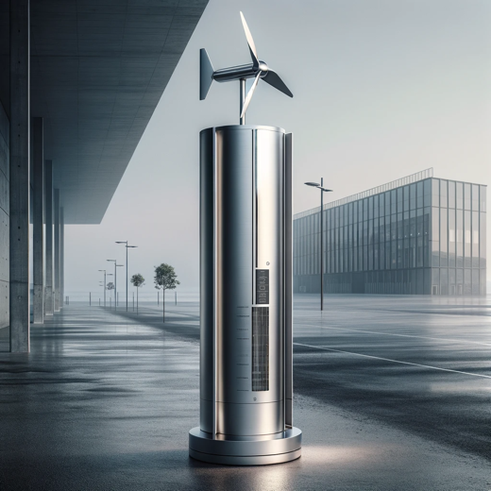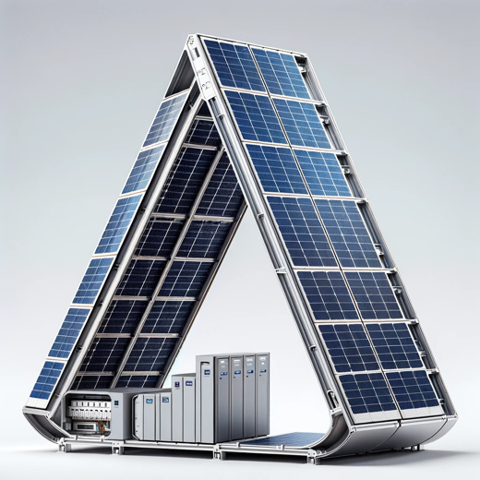

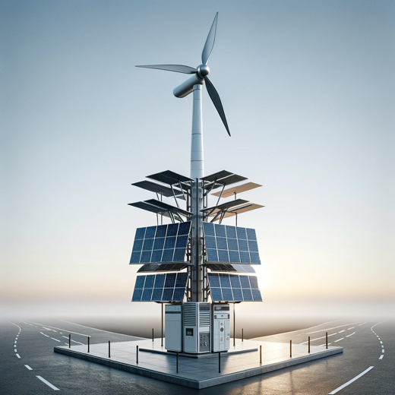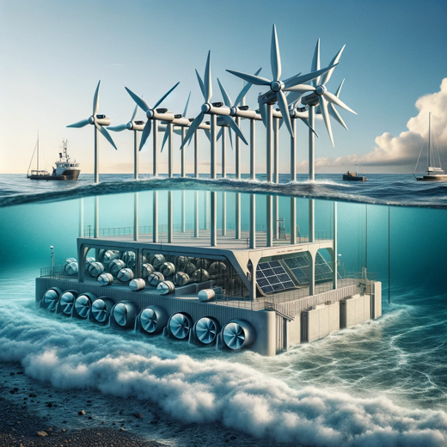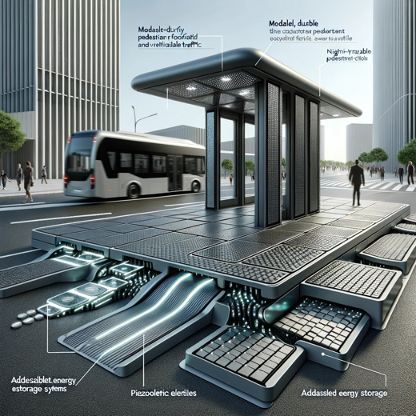

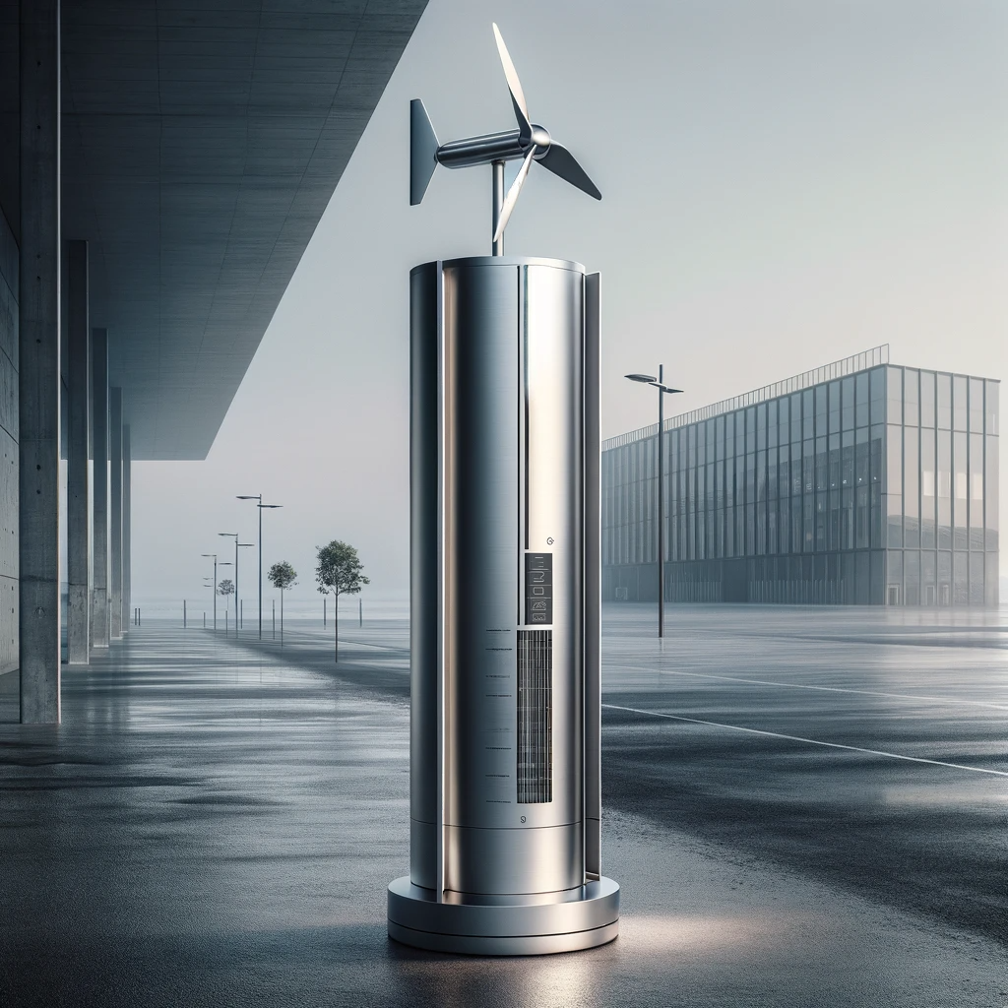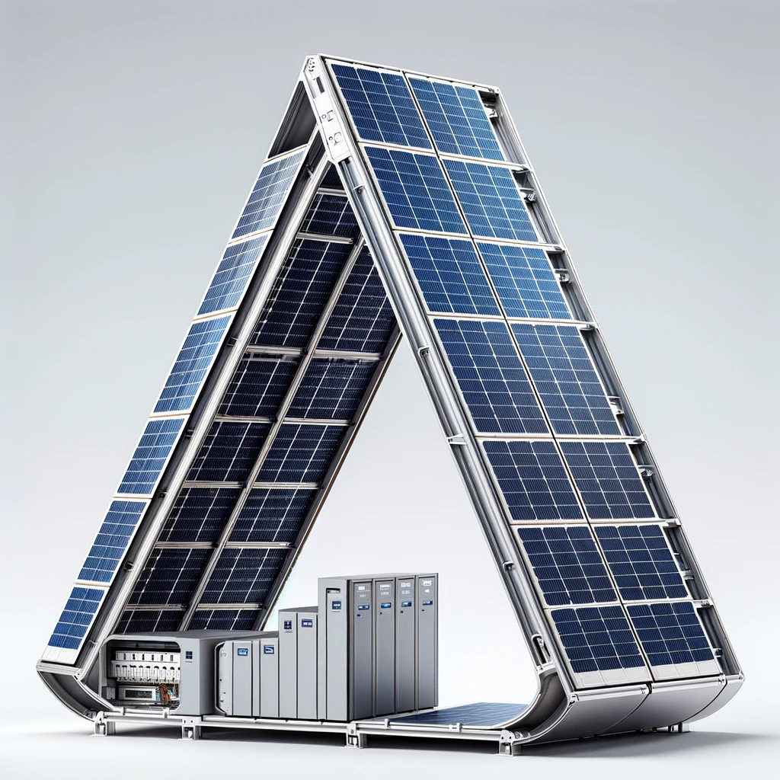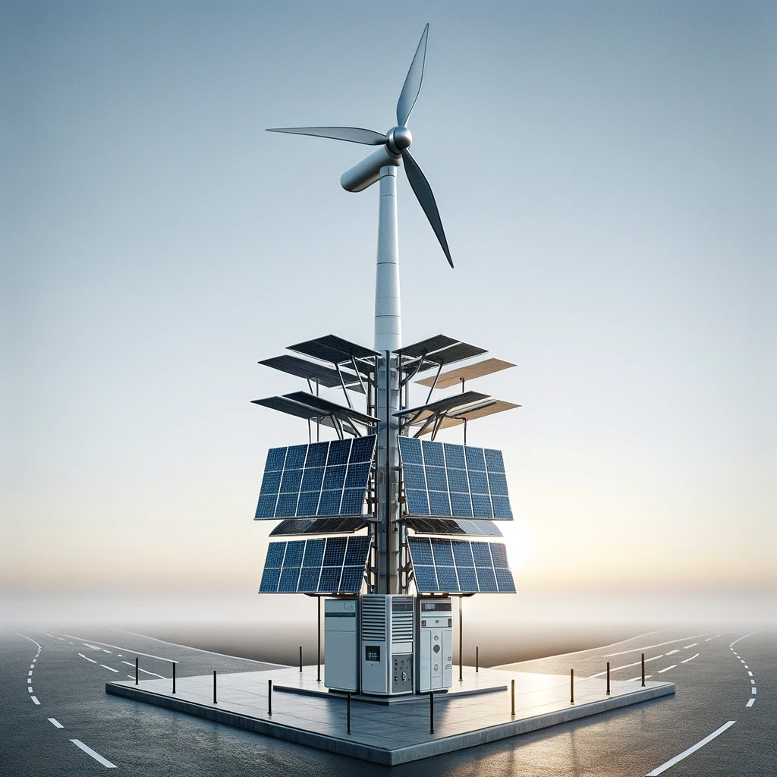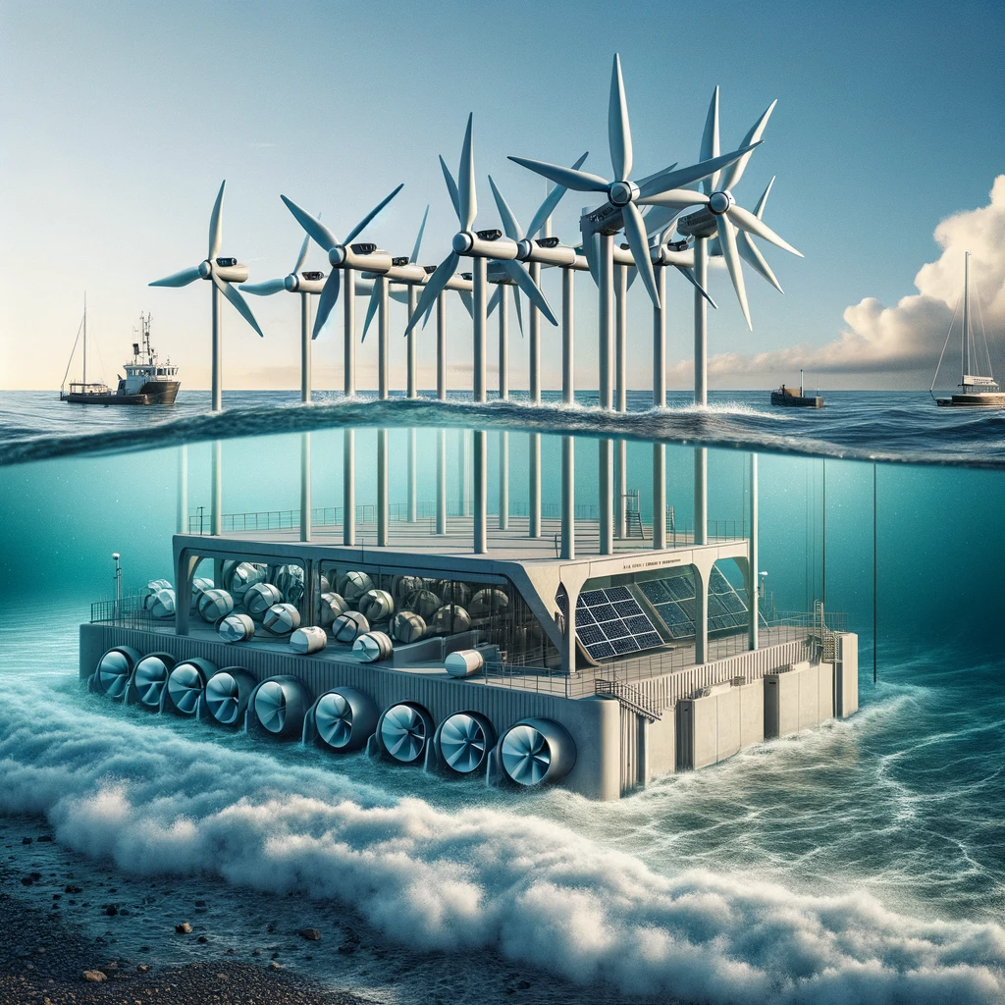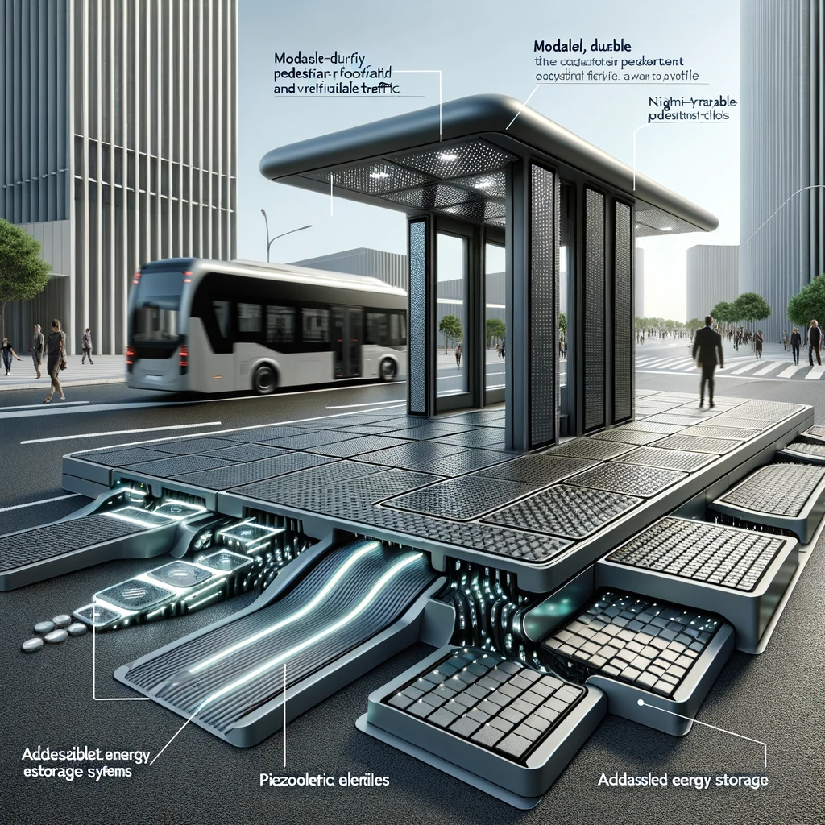窗体顶端

窗体底端